**Testing RESULT**

## Left camera ##

imgL = cv2.imread(r'C:\Users\khan1\Desktop\Projective_transform\two_camera_homography\checkerboard_high\l.jpg')

## right camera ##

imgR = cv2.imread(r'C:\Users\khan1\Desktop\Projective_transform\two_camera_homography\checkerboard_high\r.jpg')

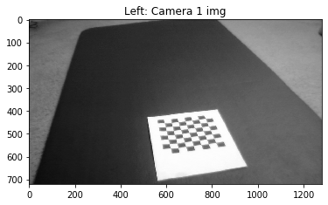

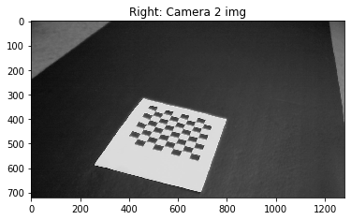

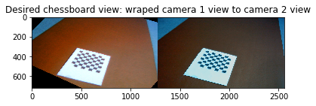

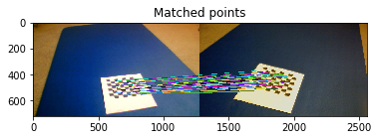

**Left Camera BB**

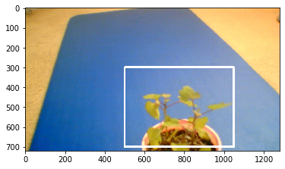

**Right Camera BB**

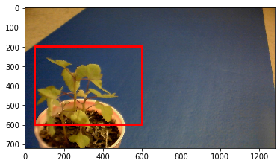

**BB Overlap without projection**

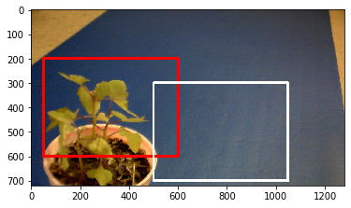

**IoU before transformation:**

**0.07317073170731707**

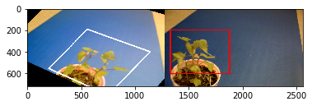

**BB when Left camera projected over right camera**

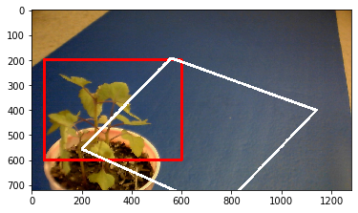

**IoU after transformation:**

**0.22330776026480664**

**For all the results below**

**"C:\Users\khan1\Desktop\Projective_transform\two_camera_homography\test_2"**

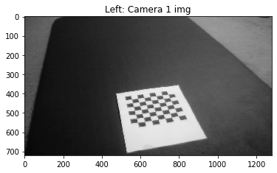

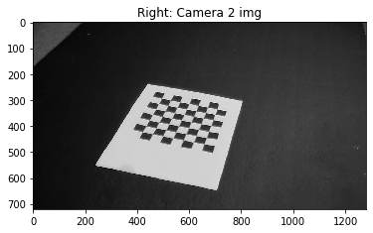

Homography matrix between camera 1 and 2, H:

[[ 9.29968576e-01 -8.34785721e-01 3.28368011e+02]

[ 3.21580417e-01 9.89425377e-01 -3.15245367e+02]

[-7.93435882e-05 5.73575359e-05 1.00000000e+00]]

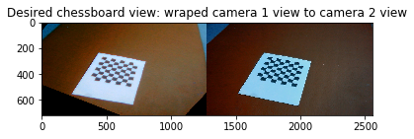

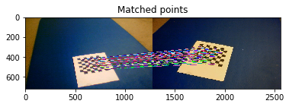

**Far image : 3 feet away**

**Close image: 8 in away**

**Result 01 (Center too close)**

**"C:\Users\khan1\Desktop\Projective_transform\two_camera_homography\test_2\center\tooclose_left.jpg"**

**"C:\Users\khan1\Desktop\Projective_transform\two_camera_homography\test_2\center\tooclose_right.jpg"**

**Left Camera BB**

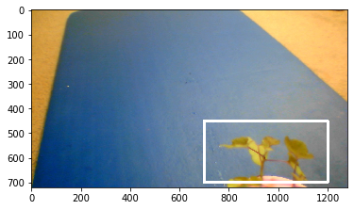

**right Camera BB**

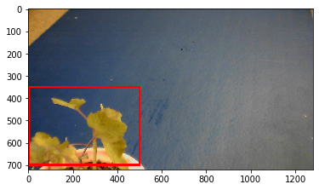

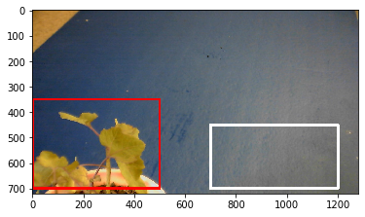

**IoU before transformation:**

**0.0**

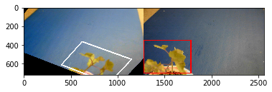

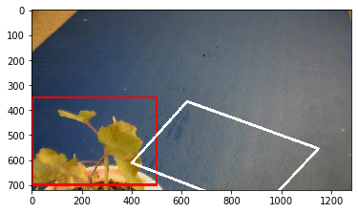

**IoU after transformation:**

**0.021490522627661**

**red_bb = Polygon([(0,350), (0,700), (500,700), (500,350)]) #Top left, bottom left, bottom right, top right**

**white_bb = Polygon([(700,450), (700,700), (1200,700), (1200,450)])**

**white_bb_transform = Polygon([[622, 366], [401,611], [910,807], [1148, 554]])**

**Result 02 (Center close)**

**"C:\Users\khan1\Desktop\Projective_transform\two_camera_homography\test_2\center\close_left.jpg"**

**"C:\Users\khan1\Desktop\Projective_transform\two_camera_homography\test_2\center\close_right.jpg"**

**Left Camera BB**

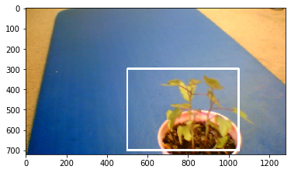

**Right Camera BB**

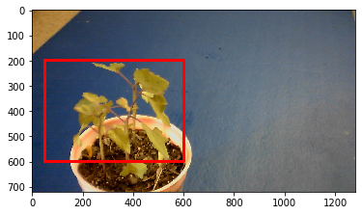

**BB Overlap without projection**

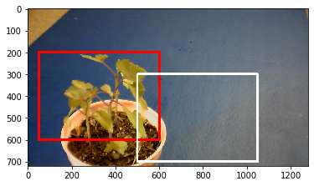

**IoU before transformation:**

**0.07317073170731707**

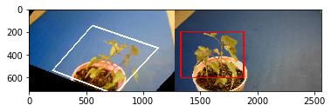

**BB when Left camera projected over right camera**

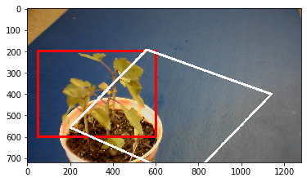

**IoU after transformation:**

**0.22330776026480664**

**Result 03 (Center med)**

**"C:\Users\khan1\Desktop\Projective_transform\two_camera_homography\test_2\center\med_left.jpg"**

**"C:\Users\khan1\Desktop\Projective_transform\two_camera_homography\test_2\center\med_right.jpg"**

**Left Camera BB**

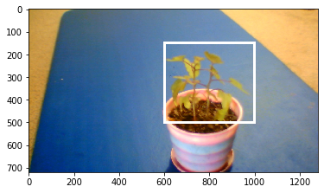

**Right Camera BB**

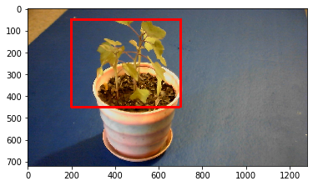

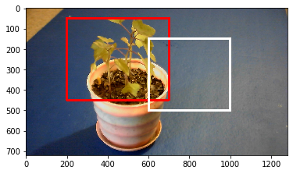

**IoU before transformation:**

**0.0967741935483871**

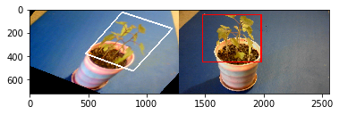

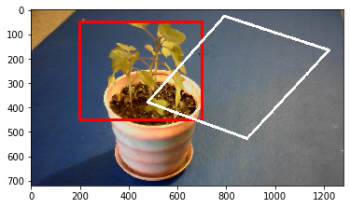

**IoU after transformation:**

**0.10155956563927257**

**red_bb = Polygon([(200,50), (200,450), (700,450), (700,50)]) #Top left, bottom left, bottom right, top right**

**white_bb = Polygon([(600,150), (600,500), (1000,500), (1000,150)])**

**white_bb_transform = Polygon([[792, 27], [478, 379],[885, 527], [1220, 166]])**

**Result 04 (Center far)**

**"C:\Users\khan1\Desktop\Projective_transform\two_camera_homography\test_2\center\far_left.jpg"**

**"C:\Users\khan1\Desktop\Projective_transform\two_camera_homography\test_2\center\far_right.jpg"**

**Left Camera BB**

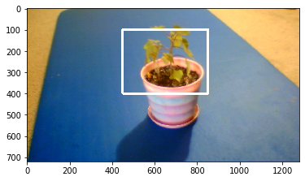

**LstartX, LstartY = 450,100**

**LendX, LendY = 850,400**

**Right Camera BB**

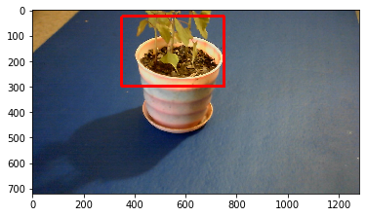

**RstartX, RstartY = 350,25**

**RendX, RendY = 750,300**

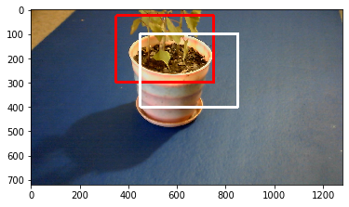

**IoU before transformation:**

**0.35294117647058826**

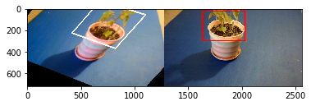

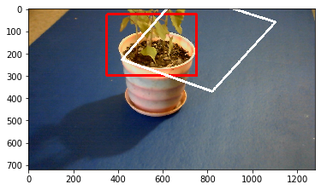

**IoU after transformation:**

**0.3171018437859914**

**red_bb = Polygon([(350,25), (350,300), (750,300), (750,25)])**

**white_bb = Polygon([(450,100), (450,400), (850,400), (850,100)])**

**white_bb_transform = Polygon([[683, -73], [418, 228],[821, 370], [1103,60]])**

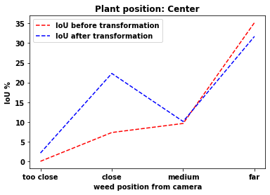

**Results 8(center far)**

**pix_x = 500**

**pix_y = 350**

**LstartX, LstartY = 425,100**

**RstartX, RstartY = 325,0**

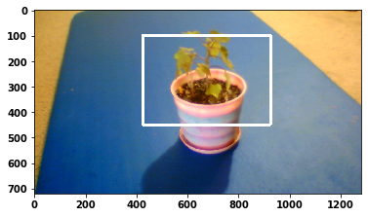

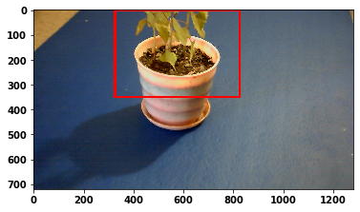

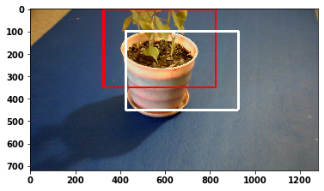

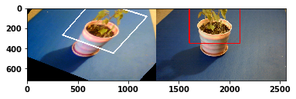

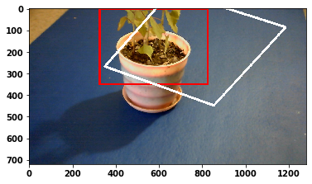

IoU before transformation:

0.4

IoU after transformation:

0.43264887332313046

**Results 9 (center med)**

**pix_x = 500**

**pix_y = 350**

**LstartX, LstartY = 500,200**

**RstartX, RstartY = 225,50**

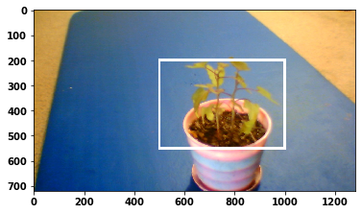

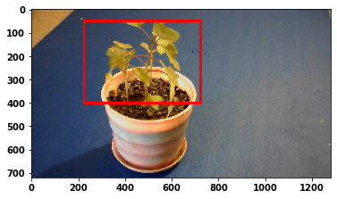

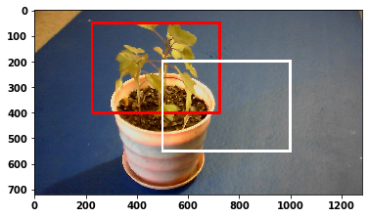

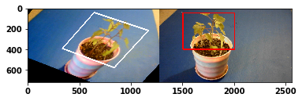

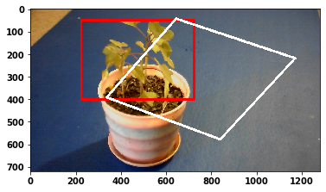

IoU before transformation:

0.14754098360655737

IoU after transformation:

0.2509125101687456

**Results 10 (center close)**

**pix_x = 500**

**pix_y = 350**

**LstartX, LstartY = 600,325**

**LendX, LendY = 1100,675**

**RstartX, RstartY = 125,225**

**RendX, RendY = 625,575**

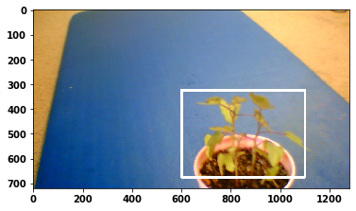

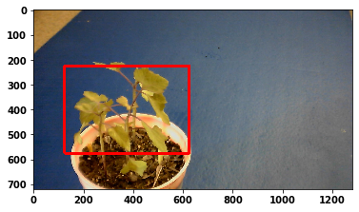

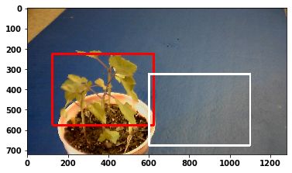

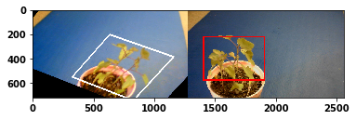

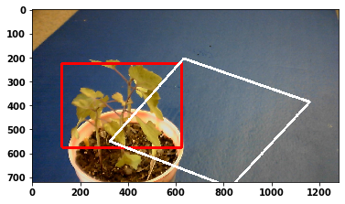

**IoU before transformation:**

**0.01818181818181818**

**IoU after transformation:**

**0.15842463349060357**

**Results 11 (center tooclose)**

**pix_x = 500**

**pix_y = 350**

**LstartX, LstartY = 700,360**

**RstartX, RstartY = 0,350**

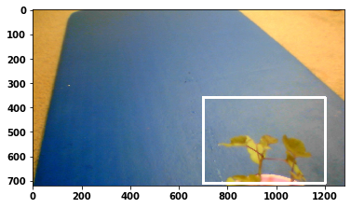

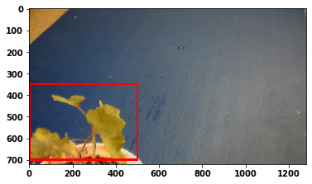

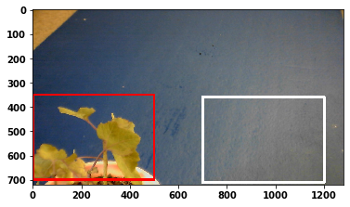

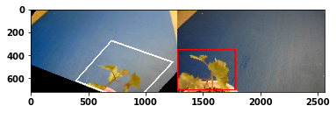

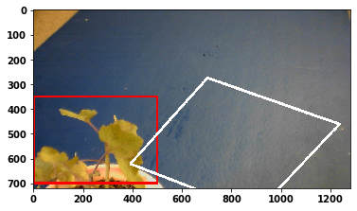

IoU before transformation:

0.0

IoU after transformation:

0.021078859582312003